**CHAPTER I**

**INTRODUCTION**

The Alumni Tracking System with Career Services bridging the Gap between Alumni and Employment is a web application that tracks alumni employment status and whereabouts. The system can also overview the employability of alumni through graphical charts. The system generate credentials of graduates, maintains a database, serving as a resource for tracking and reporting requirements needed by school institutions. This system connects alumni, institutions, and creates opportunities for mutual benefits. Employers can post jobs, alumni can apply, and institutions can track employability. Alumni are the most important parts to an institution's development, representing the school beyond campus. According to Gopakumar, V. T. (2023), alumni act as ambassadors, serving as reflection of the quality of education provided through their professionalism evidenced by employment. Engaging with alumni strengthens and improves educational programs and enhances the institution’s reputation.

Educational institutions struggle to maintain a connection with their alumni because some may become disconnected due to changes in their personal information or could be the length of time that has passed since they graduated, which may have caused them to lose interest or just feel disconnected. According to Laila M. Alegado (2015), these are the common issues including a lack of communication with graduates because of the outdated graduate profiles. This makes it difficult for the school to reach out and determine the current employment status of alumni if some unemployed or some find employment in their chosen fields. Educational institutions must adapt modern technology to enhance alumni engagement, recognizing it as an opportunity for alumni to track employability and also offers career services to meet the evolving needs of graduates and employers. According to Sadi, S., et al (2015), they currently live in a modern society where most people use smartphones to stay connected, informed, entertained, and perform tasks efficiently. The alumni tracking system with career services bridging the gap between alumni and employment presents an opportunity that needs to be utilize for school institutions as it provides opportunities for unemployed graduates seeking jobs. It also allows the institution to do things faster in tracking of alumni employment status or whereabouts.

Alumni tracking system with career services bridging the gap between alumni and employment is to keep in touch with the graduates, help the educational institutions to identify whether graduates are employed or not. As stated by MihirJayavant (2018) on his published article, the alumni tracking system web-based application helps to track former students which can improve the tracking of college graduates in a modernize way, making it more advanced and faster in tracking of alumni. It can aid in providing alumni data or information to college faculties, which eventually makes the overall process more efficient.

The system can be used as a reliable and convenient system wherein, the school institution tracking alumni information seems a burden especially when it comes to track the employment status of graduates. It aims to establish a web application with job posting features that offers career opportunities for alumni to find their career paths, fostering connections between graduates, schools, employers and effectivelyengage with the graduates and keep alumni records. Thus, its haves a group chat which allow alumni to interact and participate in group discussions within the platform thatleads to a better network to the institution. Former students and graduating students are encouraged to update their default account to have and own it, to maintain communication and stay updated on group discussions and job postings.

**Statement of the Problem**

The administration struggles to keep alumni informed about their employment status because of the outdated information of graduates as stated by Laila M. Alegado (2015). Despite efforts to reach out all the graduates quarterly, some alumni do not respond. The lack of responsiveness from certain alumni to administrative notifications asking for the latest information on graduate's employment status, making it difficult for the administration to stay informed about the graduate's employment status. Specifically, the present study seeks to answer the following questions:

1. What is the current process used by the Planning office of the university

in terms of managing its alumni 's employability data and records?

2. What is the level of difficulty encountered by Central Philippines State

University Planning Office San Carlos campus in terms of;

a. Notification of alumni student to fill-up employability tracer form.

b. Consolidation of employability of the alumni students in San Carlos campus.

c. Representation of percentage of employed students.

3. What are the technical requirements needed in the Alumni Tracking with Career Services bridging the gap between Alumni and Employment?

4. How efficient and effective is the developer of Alumni Tracking with Career Services bridging the gap between Alumni and Employment for Central Philippines State University?

**Objectives**

The project aims to increase alumni engagement, intellectual and human

resources according to Tulankar, S., & Grampurohit, B (2020), as alumni sustaining schools through donations and voluntary efforts. By implementing the system, it focusses on alumni records to keep all the alumni information in easiest way, better communication to stay in touch with the alumni and determine the employment status while saving time for manual data entry. The system will allow the university to trace alumni information and can be monitor employability. Alumni can also interact with the potential employers and post multiple jobs to help alumni find employment in their specific skills or in their field of study.

Specifically, this project aims to:

1. To create an application that will store and archive the alumni employability's information which are needed by the university.

2. To develop an application that can track and monitor the current employability status of the university's alumni.

3. To consolidate all the collected employment data of CPSU San Carlos Campus that can be represented through graphical charts.

4. To create a repository of alumni's employability data that can serve as a baseline data for university's planning and decision-making.

5. To provide graduates career services and facilitating connections between institutions, alumni and employer.

**Significance of the Study**

The result of the study will help the university to stay connected with its alumni and intended to improve the tracker system of the school. It saves time and efforts of the school to track the alumni. This project study will benefit the following.

**The CPSU Administration.** This study will help university administrations

especially the Plannings Office in tracking alumni whereabouts and can easily informed if there's a school related event. This can also benefit the university for its future decision making and strategic planning.

**The Alumni.** Former students can easily access of job opportunities and find employment. This ease of access encourages alumni to create an account before they can graduate to stay updated.

**CPSU San Carlos Campus.** This study will help San Carlos campus to

have a diverse way to track the alumni information and determine the employment status which can lessen their workload.

**Future Researchers.** This study will serve as relative information for other

researchers and can serve as basis in developing their own web applications and tracking system for creating their own version of the Alumni Tracking System for future use.

**Scope and limitations**

This capstone project, titled ‘Alumni Tracking System with Career Services bridging the gap between Alumni and Employment,’ is an integrated study in developing a web application for collecting, storing data, to manage and maintain alumnirecords such as tracking of employment status and whereabouts of alumni. It also generates graduates’ credentials, create group chats and job posting.

This web application will be implemented to the CPSU San Carlos campus system and helping them to accommodate its task in tracing the employability of their alumni. Only the registrar of the university has the privilege to upload a CSV (Comma-Separated Values) file of the students. system. An application will be introduced to the students after they graduate, for them to update their account and employability status upon their employment. The system is not capable to force users to update their account and employment status for this decision will be upon the discretion of the alumni. The system will also not filter the falsification of the details inputted by the users.

**Definition of Terms**

**Alumni.** In this study, it refersto aformer student who have attended or graduated from the educational institutions.

**Database.** In this study,it refers to a storage component of the system where files and data are stored, organized and managed.

**Career Services.** In this study, it refers to career opportunities designed to help alumni find jobs while connecting with potential employers.

**Employers.** It refers to someone who owns or manage a company business and provide jobs, hire people to perform various tasks.

**Repository.** In this study, it refers to a central location where all resources are stored and managed.

**Admin.** In this study,it is a person who oversees the system and manages its contents.

**Users.** In this study, it refers to a person who uses the system and interacts with it.

**Web App.** In this study,refers to the network connections and accessibility of the system via web browsers

**Tracking.** In this study,to find out the employment status and whereabouts of alumni.

**CHAPTER II**

**REVIEW OF RELATED LITERATURES AND SYSTEMS**

This chapter provides a review of related literature and studies that will help the researchers gather basic data and references for the current study. Important facts were provided by the researchers that presents a comprehensive summary of existing research and studies to support the significance and relevance of the Alumni Tracking with Career Services bridging the gap between Alumni and Employment systems’ creation.

**Foreign Literature**

According to the Thomas, G. G., & Wagiu, E. (2019), graduate is one of the important supports in the development of a university. Graduate have a role to assist universities in developing the university into the community through collaboration in academic terms which also stated by Anggraeeny, L., Oktafia, R., & Hidayatulloh, H. (2020), the alumni are the representatives of the institution's quality, greatly influence community perceptions and school choices. The study explores alumni contributions to extracurricular activities, advocacy for school quality, networking, mentoring, event support, and curriculum evaluation and observation. In relation, the study highlights how important role of alumni in educational institutions. The proponent used this as a basis in implementing an alumni tracking system that can enhance the school institution's visibility and reputation, ultimately contributing to its growth and success.

According to D. Yuniarto, A. Subiyakto, E. Firmansyah, I. Fadil, A. Sani and M. Irfan, the use of Information Systems for Alumni Tracking has become a major dilemma. But the Tracer Study Information Systems in private higher education found that the system is not fully effective yet an unable to provide satisfactory solutions for alumni tracking. The purpose of this study is to determine the success of using tracer study. As stated by Safi’i, Priyo Priyantoro (2019), one way to find out the condition of alumni is to do a tracer study. Tracer study or alumni tracking is information gathering activities of alumni regarding the competencies needed by stakeholders as material for the process of improving education. It serves as a valuable reference for the researcher’s system to focus on developing or improving an alumni tracking system to better serve the needs of both the institution and its alumni.

According to Ali Fikri Hasibuan and colleagues (2022) emphasize the role of alumni in evaluating teaching quality at Medan State University. They conducted a study using surveys and data analysis to assess alumni skills and job status. Findings indicated that graduates were well-prepared for jobs, quickly found employment, and satisfied their employers. This study highlights the importance of understanding alumni outcomes for improving educational programs. The proponent used this as a basis to develop a system that consolidate all information of former students in CPSU San Carlos campus to determine graduates career paths after leaving the university.

According to Akbar, R., Imilda, Sarboini, & Junaidi. (2022), the socialization of e-tracer study for college of alumni aimed to educate alumni about the significance of mapping graduates as a quality measurement standard for universities. In relation of the alumni tracking system with career services bridging the gap between alumni and employment is to facilitate a communication platform to have a better engagement of alumni, such as notifications about upcoming school activities.

According to Setyaningsih, R., Hustinawaty, Abdullah, & Prihantoro, E. (2022), the study aimed to improve higher education management. The university's Alumni Bureau requiring effective communication management. The study identified a communication management model comprising adjustment, communication planning, action, and evaluation at boarding university. It somehow related to the researchers’ system because it aims to enhance how universities interact with alumni and manage the information. The researchers seek to make tracer studies more effective in engaging alumni and collecting data, which aligns with the goal of the proponent system to create a platform for alumni information and communication, providing career services to help bridge the gap between alumni and employment.

According to Julianto Sampun (2022), the study conducted at the State University of Surabaya aims to identify and understand the satisfaction levels of graduates who participated in the PPG program from 2018 to 2020. By using interviews and questionnaires which is manual methods to collect a data from PPG graduates in the Madiun, Ngawi, and Magetan areas, as well as from the principals of schools where these graduates teach. The researchers used this study as a basis to implement a system that would make the study much more efficient. It helps to collect data and stay in touch with the graduates.

**LOCAL LITERATURE**

According to [Kathleen B. Solon-Villaneza](https://ejournals.ph/function/author.php?id=3392)*,* (2015). this study found that the majority of alumni are employed in fields related to their degree in which also stated by Tayco, R. O., Supat, P. S., & Estrop, C. P. (2022), that study shows the most of the respondents are presently employed and work locally related to the courses they have taken in college. It helps the researchers to develop an alumni tracking system with career services bridging the gap between alumni and employment web application to trace alumni employment status and determine the job alignment of graduates. It also supported in this literature by Pentang et al., (2022), the results found out that many were being employable with their related courses. The researcher’s system is an important aspect to also find out the employment status of the graduates, it is essential for universities to maintain a connection and trace the job alignment.

According to Maria Theresa B. Kalaw (2019), the presented tracer study aims to determine the graduates' employability and academic skills. The researchers used this study as a basis to improve university alumni tracking by determining the employment status and job alignment. In accordance of Evan Carlo B. Deblois (2021), the study aimed to document the graduates' profiles, the alignment between their courses and employment. The proponent learned from this study to develop a system that administrator can determine the job alignment of the graduates by collecting the data.

According to Grace L. Lopena & Dennis V. Madrigal (March 26, 2023), in this literature, the presented study evaluates the success of degree programs in business management by examining the employment performance of its graduates, as they provide and uphold the satisfaction of the school. Similarly, Abulencia et al., (2021), aimed to determine the extent of satisfaction and adequacy of the knowledge and skills that graduates have obtained from its university. The proponent learned from this study to examine the employment outcomes of the graduates and what specializations or alumni have obtained during their colleges. According to Leah Wilfreda E. et al. (2014) conducted a tracer study of BEED-SPED 2007-2013 graduates from the University of Bohol's Teachers College that tracked the progress of graduates from the Bachelor of Elementary Education with a specialization in Special Education (BEED-SPED) program. The purpose of this study was to examine how well the SPED program prepared its graduates for their careers.

According to Penera, L.K., T., Beduya, N.L., Mantos, T.L. & Gulbe, I.L. (2021), in this literature, the findings indicate the majority graduates of Cebu Technological University-Daanbantayan Campus are employed with permanent status. The researchers learned how important the alumni tracking system with career services bridging the gap between alumni and employment to track the alumni employability and to determine if the university significantly contributes to graduates' success by providing employment opportunities and evidence of such contributions, it is essential to consider various factors. Not only should the university demonstrate that it helps graduates secure employment, but it should also actively provide job opportunities for job seekers. This creates an opportunity to assist alumni in finding employment.

According to Jonathan L. Dela Cruz (2022), in this literature, the tracer study of Graduate School about graduates’ profiles, employment status and employability characteristics identifies that graduates of State Higher Education Institution in the Philippines have a very high employability rate based on the result of descriptive statistics used to analyzed the data of graduates. The researcher’s system learned from this study how important it is to have a connection with alumni to know their employment status.

**Foreign System**

According to the MihirJayavant (2018), Alumni Tracking System is an online-based application that helps to enhance the tracking of college graduates and provides alumni data to college faculties. It aims at developing a mobile application and web portal which will be useful for the college to monitor the alumni's and for the alumni to update their current status and get notified about the college activities which also stated by Bista B. et al., (2021), the alumni portal and tracking system integrates and manages alumni data, providing a portal for alumni to update their information. Both systems are enhancing alumni engagement, improves data management, and aids in understanding alumni trajectories. In relation, the proponent system aims to have an alumni engagement that provides a job portal for alumni to find their employment and can update their information making it easier to collect and update alumni. The alumni tracking system with career services bridging the gap between alumni and employment is also a web-based application to develop communication between graduates and the institution, where employers and admins of the school can communicate with alumni, enhances alumni engagement and update current status. In accordance of Suresh Kumar T. et al., (2019), this system is a platform were enabling them to connect and stay updated.

According Sadi, S., Rachmawati, D. L., & Khannan, M. S. A. (2015). the development of the technology has become increasingly rapid with almost everyone currently having a handphone. With the widespread use of Android smartphones, presenting an opportunity for institutional development especially in tracking alumni. To address this, Sadi, S., Rachmawati, D. L., & Khannan, M. S. A. (2015), developed an Android app to track alumni includes maintaining updated contact information, tracking career progress, and facilitating communication between alumni and the institution. This system is similar to the researchers’ system which is to track former students and enhance institution's ability to stay connected with its graduates and supports alumni networking with career services.

According to the Miftahul Khair (2016), this system efficiently collects and organizes alumni data, facilitating better information dissemination to alumni, current students, and faculty members. It serves as a communication, providing useful information to its users and tracking the career progress and employment status of alumni. Similarly, Sucipto, S., et al (2020), the system collects data, accessibility, communication, usability, and overall performance in assessing alumni achievements in Vocational Schools in Kediri. In relation, the proponent system aims to improves communication between schools and alumni. By collecting the data on graduates according to of P W Yunanto et al (2021), the system provides valuable feedback for improving the education process, curriculum and student activities, improving the quality of graduates and enhancing the education process. Additionally, making it more effective to track alumni and monitor the achievements and progress of the graduates.

According to P. Kumar, S. Swetha and M. Sundari *(*2023), the Secured Web-based Alumni Network and Information Systems focus on facilitating communication, providing opportunities for career advancement, fostering mentorship, and ensuring security. The system aimed to strengthens the relationship between the college and its alumni while benefiting current students. This system recognizes the value of keeping in touch with graduates that focus on communication and engagement through an online application. In relation to the researchers’ system aims to maintain a connection to communicate alumni, and providing opportunities for career advancement.

According to IJSRD or the International Journal for Scientific Research & Development (2015), the student alumni system provides the way in which alumni can stay connected with school which has been very important part of their memory. It somehow related because SAS will give announces for further opened new avenues of job. This study is a similar of the researcher’s system which serves as a platform that gives announcement about multiple jobs that posted on the system.

**Local System**

According to Aramil, J. A., et al., (2015), the research developed a web application to help the alumni officer resolve the tedious and time-consuming method of managing and retrieving alumni data and to provide affiliate companies a means of disseminating job opening information to Letran alumni applicants. In relation to the development of alumni tracer management system is to lessen the burdened of school faculties in tracing the alumni whereabouts and employment status. It manages alumni information to easily track alumni data. Additionally, the system provides career services or a job opening information for those job seekers.

According to Arbaja, J. S., Sarmiento, J. R., & Bausa, M. E. (2023), this system helps the institution effectively track, manage, and analyze alumni data, ultimately contributing to better educational strategies and outcomes. To trace the ACI alumni employment status, work alignment, and job whereabouts, as well as collect a high rate of data collection from the alumni utilizing an internet-based system for alumni records. In relation, the proponent system can facilitate tracking of alumni employment status, collect and manage information.

According to Jenny Rose V. Wenceslao (2022), the App-based Alumni Tracer System with Statistical Support was specifically developed for the purpose of bridging the gap between alumni and the schools with the use of a computer-based solution employing web and mobile technologies. This system is for maintaining communication and monitoring alumni status. It gathers and manages alumni data through web and mobile interfaces. It related to the researchers’ system because it maintains connection of the graduates and its school institutions, manage alumni information, and monitor employment status. By the development of alumni tracking system with career services bridging the gap between alumni and employment, the university get a simple way to keep track of the alumni data.

According to Etcuban, J. O. & Durano, D. S. (2015), databases for alumni are vital to every learning institution. The data and information are needed by the school to communicate, verify, archive and research the alumni. The study aimed to design and develop an alumni database of the University of Cebu that would provide solutions to problems in tracing alumni. The proposed system would enable users to register as well as generate information for the purpose of tracing the whereabouts of the alumni. This system managing alumni information and facilitating communication and engagement between the university and its alumni. In relation of the proponent system aims to keep in touch with the graduates, manage relationships, gather necessary information and keep the records to aid administrator or the school faculty trace the employability and determine how effectively instructions in the college are, through the achievements of its graduates.

According to Alegado, L.M (2015), the internet is a powerful tool for connectivity. It has become the avenue for most people to exchange information, knowledge, and apparently, almost everyone is present on the web. This study is a web system designed to help graduates stay in touch and get information within school institutions programs. In relation to the alumni tracking system with career services bridging the gap between alumni and employment aims to have a better communication between graduates and institution, to stay connected and get information about job opportunities on the system.

According to Jenny May T. Cinco and Raphy A. Dalan, (May 2019), the Web-based Alumni Network and Database Information System with Mobile Application system aimed to design, develop and evaluate to facilitate the network of alumni and a database system with the application of web technology and mobile phone. Alumni can build their network in the website or in the mobile apps in order to develop a network. The information of the alumni will be saved in the database for several purposes. The proponents learned from this study to implement a system that tracks alumni and effectively connecting in alumni, manage information, and stay updated in every news to enhance alumni engagement.

According to [Glenn Trinidad](https://www.researchgate.net/profile/Glenn-Trinidad?_tp=eyJjb250ZXh0Ijp7ImZpcnN0UGFnZSI6InNpZ251cCIsInBhZ2UiOiJwdWJsaWNhdGlvbiIsInByZXZpb3VzUGFnZSI6Il9kaXJlY3QifX0) (2023), the purpose of the system is to determine the importance of developing a web-based [alumni](https://www.researchgate.net/publication/371161518_ACCEPTABILITY_OF_WEB-BASED_ALUMNI_TRACING_AND_JOB_SEARCH_SYSTEM_DWAT-JS?_tp=eyJjb250ZXh0Ijp7ImZpcnN0UGFnZSI6InNpZ251cCIsInBhZ2UiOiJwcm9maWxlIiwicHJldmlvdXNQYWdlIjoicHVibGljYXRpb24ifX0) tracing and job search system for tracking and monitoring alumni records, allowing for easy access to information about former students and to provide job search or opportunities for CTU Naga Extension Campus, help alumni in finding relevant job opportunities after graduation. It related to the researcher’s system that monitor and tracks employment status of graduates and provide job opportunities for the former students of the school or on the campus.

According to Joery et al., (2023), the Online Monitoring and Tracking System for Dormitoryaims to provide a centralized platform. This system is used to enhance student monitoring which also related to the system of Borlio et al., (2015), aimed to create a tracking system to monitor the current location of visitors or students inside the University. In relation of Capili-Kummer, M. G., & Corpuz-Batuga, M. L. (2021) system, was developed to centralized a platform for alumni monitoring to gather up-to-date information of graduate’s employment status and maintaining alumni information using web-based system. Then send notifications through alumni registered email address. The proponent’s system is somehow related to this system that also a platform to maintain alumni information. It enhances alumni communication, interactions between alumni and the university, track whereabouts and employability.

According to Adrian Regalado Date (2023), the alumni management system is a web-based platform designed to enhance communication between former students and their institution. It helps colleges maintain strong alumni networks by keeping detailed records and promoting ongoing relationships. Columban College Inc. values this connection, as alumni represent the school post-graduation. The system provides alumni with updates, events, and job opportunities, which similar to the researchers’ system that also provides alumni updates about job opportunities, maintain a strong connection of the graduates and enhance communication.

**CHAPTER III**

**METHODOLOGY**

This chapter presents the methodology that will be used in this project, providing a detailed explanation of the design method, and discussing each phase of the chosen model. The flow of the study will also be explained as well as functional and non-functional requirements, system workflow, flowchart, system architecture, and diagrams. Additionally, this section will describe the environment of the study, the instrument and data gathering procedure.

**Design Method**

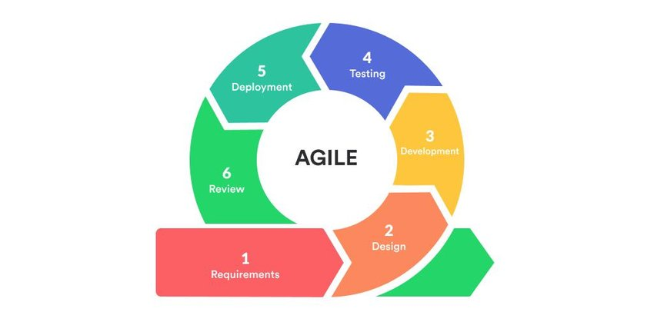

Figure 1. Agile Model (Software development life cycle)

Figure 1. agile model (Software development life cycle)

The Agile methodology is a project management approach that involves breaking the project into phases and emphasizes continuous collaboration and improvement. It promotes collaboration among team members and encourages regular feedback and improvement throughout the project lifecycle. The researcher followed the phases of agile methodology. By breaking the project into phases, it allows for better planning and organization of tasks.

In the planning stage, the proponents collaborate with their adviser to collect information with the underlying problems of manual work at research office. Interviews were held with the research coordinator in order to understand the whole process of taking the tracing the alumni to the advantage of the researchers. Based on the collected information, the researchers will come up with a great plan on how to solve the problem of tracing the alumni in a better and efficient manner. This stage of planning is very important, making sure that all resources to be used are fully utilized, and the proposed solution is tailored to the needs of Central Philippine State University. All in all, the planning stage is a very crucial stage in the research process since it lays the groundwork for successful solution of the identified problem.

The second stage is the stage of design.prototyping is utilized to visually conceptualize the system. It aims to create a system that not only meets functional requirements but also delivers an intuitive and visually appealing user experience for the Alumni Tracer Management System of Central Philippine State University.

Development phase. The proponents will begin developing the system using Vuejs(JavaScript framework), Tailwindcss, and primevue for the front-end, and Express js (Node. js framework) and Firebase for the backend. This phase marks the transition from design to the creation of a functional and interactive system. Collectively, the combination of this technologies ensures a visually appealing and responsive front-end interface.

The testing stage is of major importance in making sure that the system is fit to meet the end-user's requirements. Some of the identified issues related to the system were dealt with, making sure the system functions at an optimum level and meets the requirements of the end-users through beta testing and surveys.

During deployment. After thorough development and testing of the system, the next step is to deploy it online. This stage ensures that the system is made available to who has account to the alumni trace management system. This ensures that end-users can access and benefit from the system's features, marking the completion of the development process.

It also focuses on the review of specific functions and errors to ensure the system functions optimally. Developers can look at the system functions with regard to identifying and fixing issues with the system before the system is released to the end-users. This review also needs to cover UI functions, security functions, and performance functions. The errors review also needs to include deployment errors, compatibility errors, and logical errors to ensure that the system is stable and secure.

**Input-Process-Output**

The diagram in Figure 2 shows various information to input and process so that desired output will be obtained.

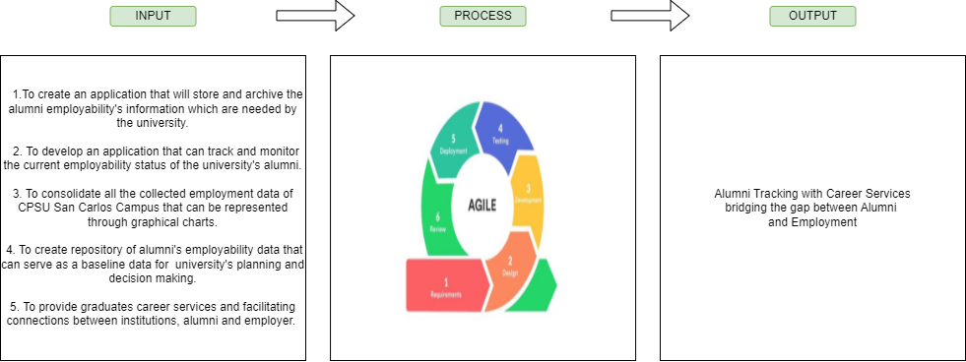

Figure 2. Flow of the study

**Functional Requirements**

The functional requirements highlighted the specific functionalities that the system should be able to perform, successfully.

* Description of the database entered into the system are:

1. Alumni information
2. Admin Information
3. Reports

**Interface Requirements**

1. Accept text and numeric data entry
2. Design is responsive to some browser

**Regulatory/Compliance Requirements**

* Only admin can use the full functions of the system
* Only registered alumni can login
* All data that be entered in the system should be accurate

**Security Requirements**

* Admin is the only can create account for users

**Non-functional Requirements**

This refers to the faculties that are non-functional. This includes the following:

**Security**

* **Login Requirements** - the user must provide valid credentials

**Performance**

* **Response time** - system load run to 5~10 seconds to display on the screen.
* **Query and reporting time** - fast retrieval and display of alumni information to answer any admin query or support report generation requirements with a time out of not more than 10 seconds to result in quick accessibility to the super admin and admin.

**Capacity**

* **Storage** - the system must handle and manage the voluminous amount of attendance data produced through scanning of the students, to perform without problems and to have easy access to information at any time.

**Availability**

* **Hours of operation** - the system is always available.
* **Location of operations** - operational site will be at Central Philippines State University campuses.

**Reliability**

* **Mean time between failures** - the system operates reliably and consistent with minimal downtime and interruptions.
* **Mean time to recovering** - the system can be restored to normal operation quickly.

**Recovery**

* **Recovery process** - depends on the nature of the failure and a type of system being recovered; the process is well defined but can vary.
* **Recovery time scale** - depends the type of failure, complexity of the system, and the recovery process.
* **Backup frequencies** - should be determined according to the criticality of the data and should be tested regularly on the probability that it works as it is intended.
* **Backup generation** - it should be available and accessible to be restored.

**Compatibility**

* **Compatibility with shared applications** - visual studio code
* **Compatibility with third party applications** - google chrome
* **Compatibility on different platforms** - the system is designed to provide compatibility with desktop computers, targeting super admin, admin and alumni across different system.
* **Conformance to architecture standards** - the system must be used in the place that has a good internet connection to make it function correctly.

**Maintainability**

* **Conformance to design standards** - HTML, CSS, JAVASCRIPT
* **Conformance to coding standards** - FIREBASE, JAVASCRIPT

**Usability**

* **Look and feel standards** - scree resolution for at least 1366x768 for proper viewing of screens.
* **Internationalization / localization requirements** - language ­– English

**Workflow – Manual Process**

This chart illustrates the manual process in tracking alumni.

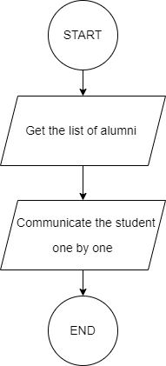

Figure 3. Workflow Diagram

**Proposed Flowchart**

This flowchart shows the process of data, where it should start and how it ends.

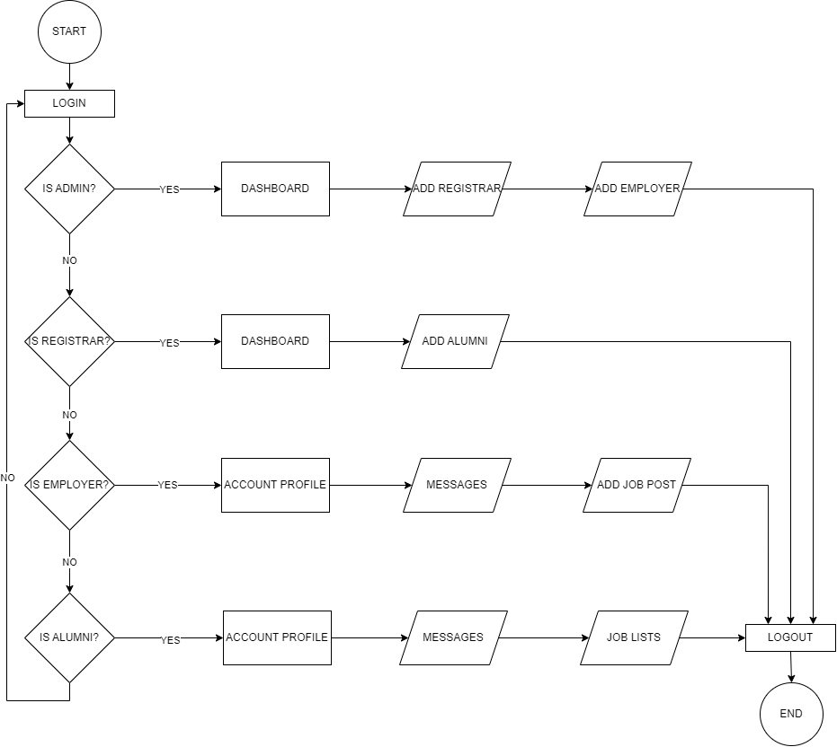

Figure 4. Flowchart Diagram

**System Architecture**

System architecture refers to the design and structure of a computer system or software application.

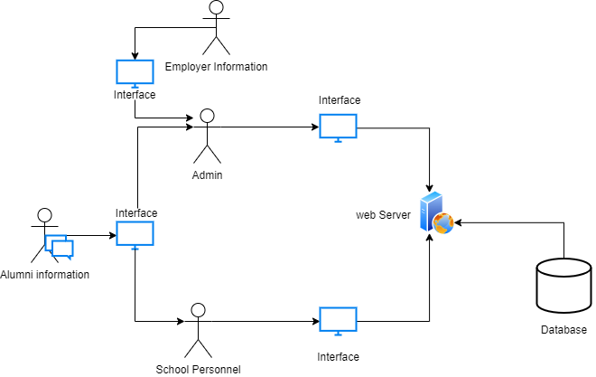

Figure 5. System Architecture

Figure 5. System Architecture

**Context Diagram**

Context diagram illustrate how the data processed by the system in terms of input and output.

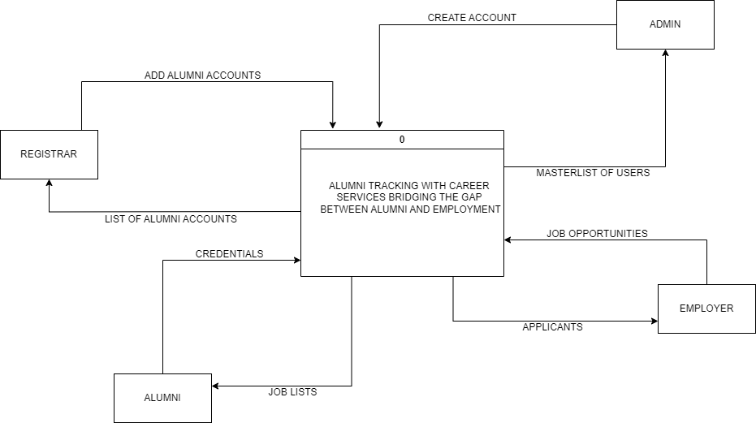

Figure 6. Context Diagram

**Data Flow Diagram**

A data flow diagram is a graphical representation of the floe of data through an information system.

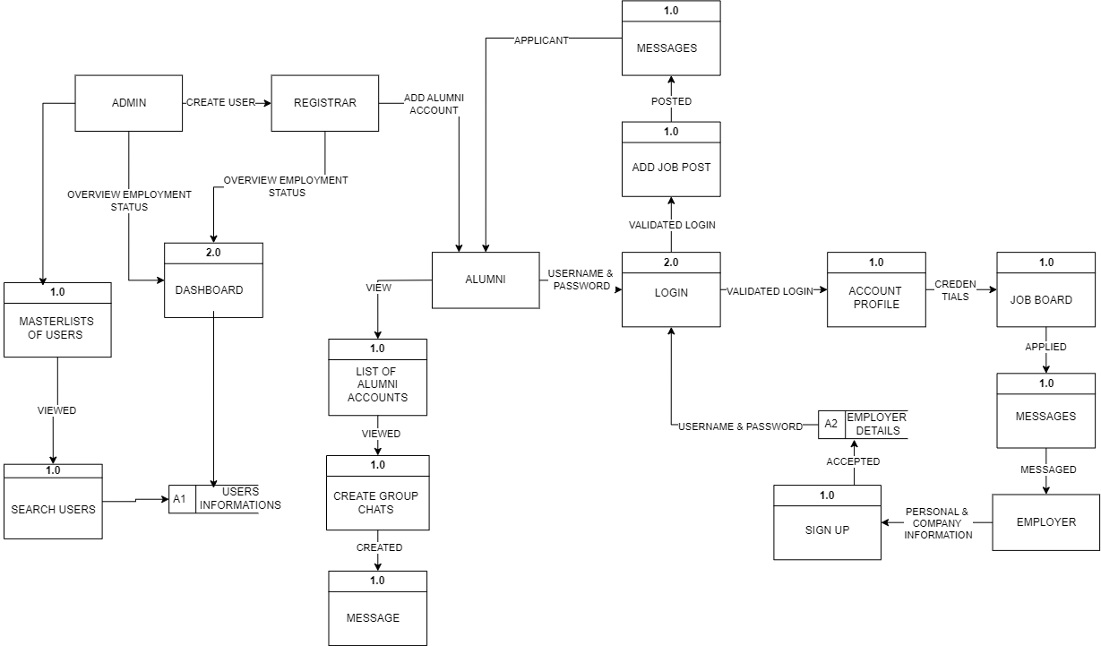

Figure 7. Data Flow Diagram

**Entity Relationship Diagram**

This diagram shows the relationship of the entities in the database.

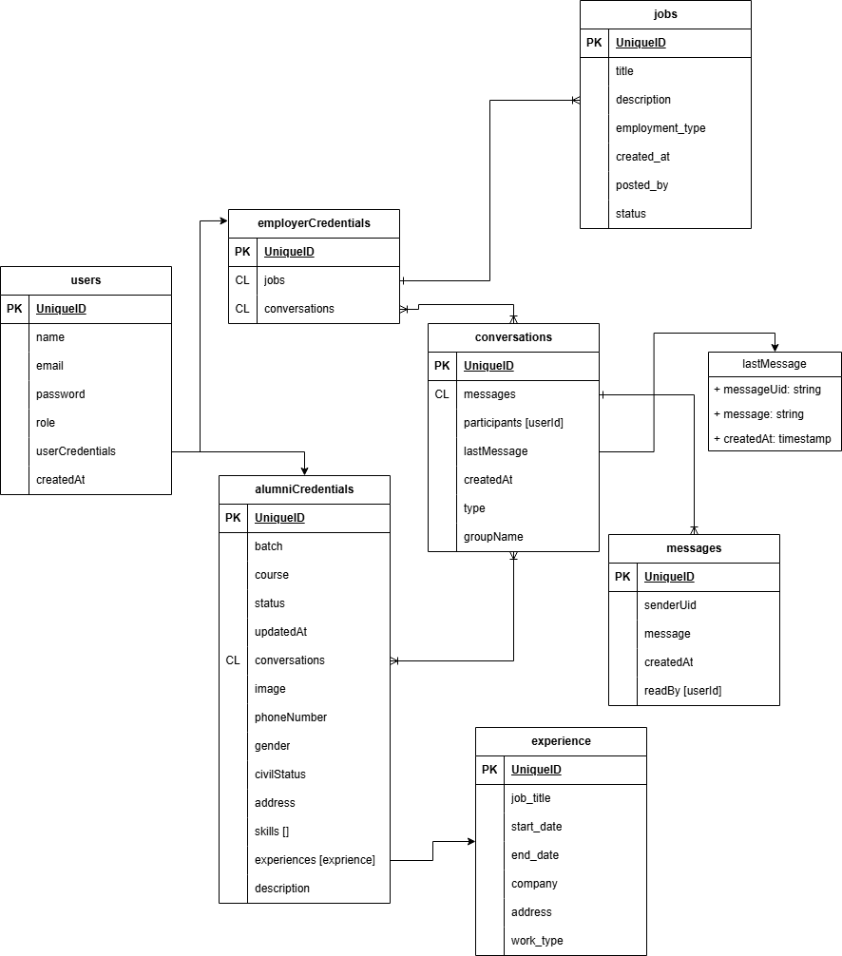

Figure 8. ERD of the System

**Use case Diagram**

A use case diagram is a visual representation of how users interact with a system to achieve specific goals or functions.

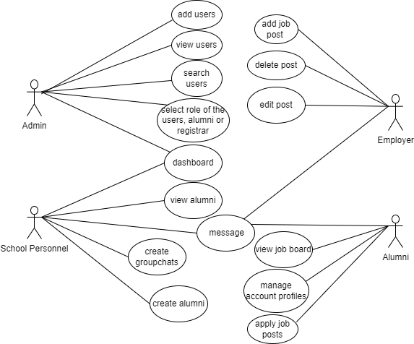

Figure 9. Usecase Diagram

**Respondents**

The respondents are the former students, school personnel, admin of the

Central Philippines State University San Carlos Campus and the employers.

Table 1. Distribution of Respondents

|  |  |  |
| --- | --- | --- |
| **Respondents** | **Frequency** | **Percentage** |
| Admin  School Personnel  Students  Employers |  |  |
| **Total** |  |  |

**Environment**

The proponents conducted the study at the university's location, specifically at Don Justo V. Valmayor Campus in San Carlos City, Negros Occidental. The study focused on the university where the system will be implemented and utilized.

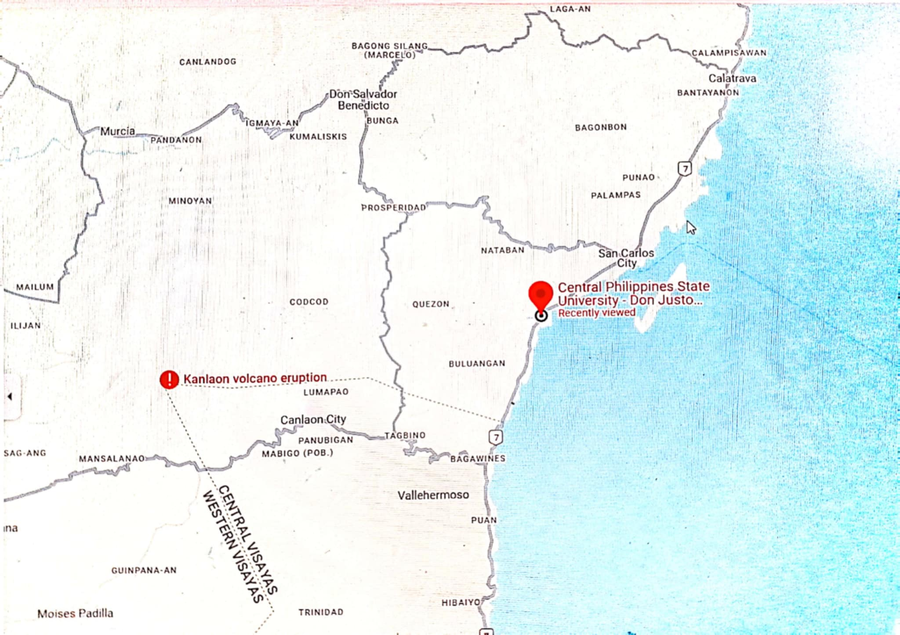

Figure 10. Environment of the study

**Data Gathering Procedures**

The primary data were obtained directly from sources through an evaluation form based on the PIECES Software Evaluation Framework, as assessed by end-users and IT experts. To conduct the study, the proponents utilized a survey method by distributing questionnaires to collect respondents' ratings of the system.

**Research Instrument and Statistical Treatment of Data**

How effective and efficient is the Alumni Tracking with Career Services bridging the Gap between Alumni and employment using PIECES Software Evaluation Framework Questionnaire. This standardized questionnaire was used in evaluating the end-users and IT (Information Technology) Expert’s satisfactory rating on the effectiveness, efficiency, and usability of this web application. The areas consist of performance, information, economy, control, efficiency and services were evaluated to assess the functionality of the develop system. For each question in each area, the respondents answered based on a structured 5-point Likert Scale with the verbal description: 1= Very Dissatisfied, 2=Dissatisfied, 3=Quite Satisfied, 4=Satisfied, 5=Very Satisfied. Items were total score and weighted mean. Items were totaled for a total score and weighted mean.

Table 2. Likert Scale

|  |  |  |
| --- | --- | --- |
| Rating | Weighted Mean | Verbal description |
| 5 | 4.21-5.00 | Very Satisfied |
| 4 | 3.41-4.20 | Satisfied |
| 3 | 2.61-3.40 | Quite Satisfied |
| 2  1 | 1.81-2.60  1.00-1.80 | Dissatisfied  Very Dissatisfied |

The following statistical formula was used in the treatment of data gathered from the respondents.

The data was evaluated using weighted mean adapted from Likert Scale.

*WM*= (*f₄* * 4) + (*f*₃ * 3) + (*f*₂ * 2) + (*f*₁ * 1)

N

Where,

WM = weighted mean

f = frequency

N = population

**CHAPTER IV**

**RESULTS, CONCLUSIONS, & RECOMMENDATIONS**

**a. Results and Discussion**

The evaluation results provide an insightful analysis of the system's performance, focusing on key areas such as effectiveness, efficiency, and usability of the Alumni Tracking System with Career Services bridging the Gap between Alumni and Employment These aspects were assessed and evaluated by end-users and IT (Information Technology) Experts. The findings reveal how well the system met its intended goals, how effectively it supports users in completing tasks, and the overall satisfaction of users with their interactions. By evaluating the system from multiple perspectives, the results offer valuable information on its strengths and areas for improvement, ensuring that the system evolves to better meet the needs of its users. The following sections discuss the detailed evaluation results and their implications for future system enhancements.

The effectiveness, Efficiency and Usability of the Alumni Tracking System with Career Services bridging the Gap between Alumni and Employment in Central Philippines State University San Carlos Campus assessed and evaluated by end-users and IT (Information Technology) Experts

Table 3. Response of the End-Users and IT Experts on PIECES Software Evaluation in terms of Performance throughout and response time.

|  |  |  |
| --- | --- | --- |
| **Indicators** | **Weighted Mean** | **Interpretation** |
| 1. Small amount of work is performed over a period of time. |  |  |
| 1. There is a delay time between transaction and a response to the transaction request. |  |  |
| **Overall Weighted Mean** |  |  |

Table 5. Responses of the End-Users and IT Experts on PIECES Software Evaluation in terms of Alumni Tracking with Career Services bridging the Gap between Alumni and Employment Information, Input, Output, and Data Storing.

|  |  |  |
| --- | --- | --- |
| **Indicators** | **Weighted Mean** | **Interpretation** |
| 1. Forms use were accurate in capturing data because forms don’t lack the required information which the user would fill-in. 2. Forms used to capture data was not redundantly saved because system won’t allow forms containing the same information. 3. Does not lack of required forms to capture data. 4. Reports contain complete information. 5. Reports don’t contain too much information which is not needed. 6. Reports doesn’t contain unnecessary and irrelevant information. 7. Stored Data/information is accurate. 8. Data/information is secured from accident, theft or vandalism. 9. Data/information is stored redundantly in multiple files and/or databases. |  |  |
|  |  |  |
| **Overall Weighted Mean** |  |  |

Table 6. Responses of the End-Users and IT Experts on PIECES Software Evaluation in terms of Economic Cost

|  |  |  |
| --- | --- | --- |
| **Indicators** | **Weighted Mean** | **Interpretation** |
| 1. Costs are not expensive to operate the system. 2. Supplies and materials for needed are sufficient for deployment. |  |  |
| **Overall Weighted Mean** |  |  |

Table 7. Responses of the End-Users and IT Experts on PIECES Software Evaluation in terms of Alumni Tracking with Career Services bridging the Gap between Alumni and Employment Control & Security.

|  |  |  |
| --- | --- | --- |
| **Indicators** | **Weighted Mean** | **Interpretation** |
| 1. Input data/Information is adequate to operate the system. 2. Data or Information is secure for unauthorized access.      1. Data privacy regulations or guidelines are not violated. |  |  |
| **Overall Weighted Mean** |  |  |

|  |  |  |
| --- | --- | --- |
| **Indicators** | **Weighted Mean** | **Interpretation** |
| 1. Data is not redundantly inputted or copied. 2. Data is not redundantly processed.      1. Information is not redundantly generated. 2. Effort required for tasks is moderated. 3. Materials required for tasks are not excessive. |  |  |
| **Overall Weighted Mean** |  |  |

Table 8. Responses of the End-Users and IT Experts on PIECES Software Evaluation in terms of Alumni Tracking with Career Services bridging the Gap between Alumni and Employment’s Efficiency.

Table 9. Responses of the End-Users and IT Experts on PIECES Software Evaluation in terms of Alumni Tracking with Career Services bridging the Gap between Alumni and Employment’s Service.

|  |  |  |
| --- | --- | --- |
| **Indicators** | **Weighted Mean** | **Interpretation** |
| 1. The system produces accurate results. 2. The system produces consistent results.      1. The system produces reliable results. 2. The system is not easy to learn and use. 3. The system is flexible to new, exceptional situations or change. |  |  |
| **Overall Weighted Mean** |  |  |

Table 10. Grand Mean of the Responses of the End-Users and IT Experts on PIECES Software Evaluation for Effectiveness, Efficiency and Usability of the developed Alumni Tracking with Career Services bridging the Gap between Alumni and Employment.

|  |  |  |
| --- | --- | --- |
| **Indicators** | **Weighted Mean** | **Interpretation** |
| 1. Performance throughout and response time. 2. Information input, output and data storing.      1. Economic Cost 2. Control and Security. 3. Efficiency 4. Service |  |  |
| **Overall Weighted Mean** |  |  |

**b. Implementation Plan**

Implementing the alumni tracking system with career services will simplify the process of tracking alumni information and their employment status, compared to manually entering data and individually reaching out to alumni. The system can store all records of alumni, tracks employment status, provide career services and fosters connections. The researchers plan to conduct training and orientation sessions to minimize system errors and guide end users on how to use the alumni tracking services bridging the gap between alumni and employment properly. These sessions will include hands-on demonstrations and user-friendly guides to ensure that both faculty and graduating students, who are about to leave the school and will soon be considered alumni, are comfortable with the system. Alumni will be able to manage their profiles, apply for jobs, while employers can post job openings and track alumni applications. This makes it easier to track the whereabouts of alumni, ensuring that the school personnel can access this information whenever needed.

The proponent is currently working on a system that will benefit both the school and the alumni. This system will make it easier for faculty members to monitor alumni employment status without the need to contact them individually. It will generate reports about alumni career progress and manage their personal information. The system will also include a job posting feature, where alumni can find and apply for job opportunities through the platform. Once the system is finished, it will be tested to ensure it works properly and is secure. After testing, the system will be introduced to users in stages, starting with a small group to gather feedback. This feedback will be used to improve the system by adding features and making it better suited to user needs. Once everything is ready, the system will be fully launched, and support will be provided to help users get started and make the most of the platform.

To ensure the system continues to function effectively after implementation, maintenance will be carried out. This includes monitoring the system to identify and fix any issues, and ensuring the system stays secure against new threats. User feedback will be collected to identify areas for improvement. Training and support will be provided to help users adapt to updates. Additionally, an admin will be assigned to manage the system, ensuring it remains reliable and provides long-term benefits to both end users.

**Gantt Chart**

This Chart shows the development of the activities done.

|  |  |  |  |  |  |  |  |  |  |  |  |  |  |  |  |  |  |  |  |  |
| --- | --- | --- | --- | --- | --- | --- | --- | --- | --- | --- | --- | --- | --- | --- | --- | --- | --- | --- | --- | --- |
|  | AUG | | | | SEPT | | | | OCT | | | | JAN | | | | FEB | | | |
| ACTIVIES | W1 | W2 | W3 | W4 | W1 | W2 | W3 | W4 | W1 | W2 | W3 | W4 | W1 | W2 | W3 | W4 | W1 | W2 | W3 | W4 |
| CHAPTER 1 |  |  |  |  |  |  |  |  |  |  |  |  |  |  |  |  |  |  |  |  |
| INTRODUCTION |  |  |  |  |  |  |  |  |  |  |  |  |  |  |  |  |  |  |  |  |
| STATEMENT OF THE PROBLEM |  |  |  |  |  |  |  |  |  |  |  |  |  |  |  |  |  |  |  |  |
| OBJECTIVES |  |  |  |  |  |  |  |  |  |  |  |  |  |  |  |  |  |  |  |  |
| SIGNIFICANCE OF THE STUDY |  |  |  |  |  |  |  |  |  |  |  |  |  |  |  |  |  |  |  |  |
| SCOPE AND LIMITATIONS |  |  |  |  |  |  |  |  |  |  |  |  |  |  |  |  |  |  |  |  |
| DEFINITION OF TERMS |  |  |  |  |  |  |  |  |  |  |  |  |  |  |  |  |  |  |  |  |
| CHAPTER 2 |  |  |  |  |  |  |  |  |  |  |  |  |  |  |  |  |  |  |  |  |
| REVIEW OF RELATED LITERATURE AND SYSTEMS |  |  |  |  |  |  |  |  |  |  |  |  |  |  |  |  |  |  |  |  |
| CHAPTER 3 |  |  |  |  |  |  |  |  |  |  |  |  |  |  |  |  |  |  |  |  |
| METHODOLOGY |  |  |  |  |  |  |  |  |  |  |  |  |  |  |  |  |  |  |  |  |
| DESIGN METHOD |  |  |  |  |  |  |  |  |  |  |  |  |  |  |  |  |  |  |  |  |
| INPUT-PROCESS-OUTPUT |  |  |  |  |  |  |  |  |  |  |  |  |  |  |  |  |  |  |  |  |
| FUNCTIONAL REQUIREMENTS |  |  |  |  |  |  |  |  |  |  |  |  |  |  |  |  |  |  |  |  |
| WORKFLOW |  |  |  |  |  |  |  |  |  |  |  |  |  |  |  |  |  |  |  |  |
| PROPOSED FLOWCHART |  |  |  |  |  |  |  |  |  |  |  |  |  |  |  |  |  |  |  |  |
| SYSTEM ARCHITECTURE |  |  |  |  |  |  |  |  |  |  |  |  |  |  |  |  |  |  |  |  |
| CONTEXT DIAGRAM |  |  |  |  |  |  |  |  |  |  |  |  |  |  |  |  |  |  |  |  |
| DATA FLOW DIAGRAM |  |  |  |  |  |  |  |  |  |  |  |  |  |  |  |  |  |  |  |  |
| ENTITY RELATIONSHIP DIAGRAM |  |  |  |  |  |  |  |  |  |  |  |  |  |  |  |  |  |  |  |  |
| USE CASE DIAGRAM |  |  |  |  |  |  |  |  |  |  |  |  |  |  |  |  |  |  |  |  |
|  |  |  |  |  |  |  |  |  |  |  |  |  |  |  |  |  |  |  |  |  |
|  |  |  |  |  |  |  |  |  |  |  |  |  |  |  |  |  |  |  |  |  |
|  |  |  |  |  |  |  |  |  |  |  |  |  |  |  |  |  |  |  |  |  |

**Budget Recommendation**

The table shows the budget recommendation for the implementation of the system.

Recommended Budget for the Implementation of the System

|  |  |  |  |  |
| --- | --- | --- | --- | --- |
|  |  |  |  |  |
|  |  |  |  |  |
|  |  |  |  |  |
|  |  |  |  |  |

**c. Testing and Evaluation**

**d.1. Testing**

**d.2. Evaluation**